OPTION | MONDAY | TUESDAY | WEDNESDAY | THURSDAY | FRIDAY
A | Meatballs  & Tomato Pasta | Chicken Wrap | Gammon Roast  with Seasonal Vegetables,  Roast & Mashed Potatoes & Gravy | Cheesy Pasta | Chicken Burger  with Chips and Seasonal Vegetables
B |  |  |  |  | Fish Fingers
 | Sandwich  with a choice of fillings (Cheese, Tuna Mayo or Ham) | Sandwich  with a choice of fillings (Cheese, Tuna Mayo or Ham) | Sandwich  with a choice of fillings (Cheese, Tuna Mayo or Ham) | Sandwich  with a choice of fillings (Cheese, Tuna Mayo or Ham) | Sandwich  with a choice of fillings (Cheese, Tuna Mayo or Ham)
C | Jacket Potato  with a choice of fillings (Cheese, Tuna Mayo or Baked Beans) | Jacket Potato  with a choice of fillings (Cheese, Tuna Mayo or Baked Beans) | Jacket Potato  with a choice of fillings (Cheese, Tuna Mayo or Baked Beans) | Jacket Potato  with a choice of fillings (Cheese, Tuna Mayo or Baked Beans) | Jacket Potato  with a choice of fillings (Cheese, Tuna Mayo or Baked Beans)
Dessert  Options | Iced Sponge | Ginger Biscuits | Eaton Mess | Melting Moments | Chocolate Crunch
 | Fresh Fruit | Fresh Fruit | Fresh Fruit | Fresh Fruit | Fresh Fruit
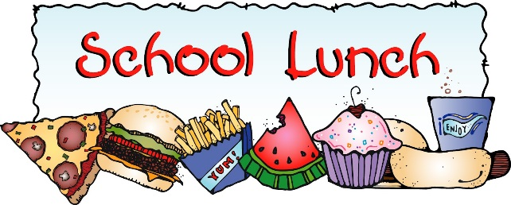
WEEK 1
2023/2024
Also available every day:
Salad, Seasonal Vegetables, Bread and Juice or Milk. Quorn is available upon request.

