OPTION | MONDAY | TUESDAY | WEDNESDAY | THURSDAY | FRIDAY
A | Brunch  Pork Sausage, Hash Browns, Scrambled Eggs, Mushrooms, Fresh Tomato & Baked Beans | Chicken Pasta Bake  With garlic bread | Roast Chicken  with Seasonal Vegetables,  Roast & Mashed Potatoes & Gravy | Sausage Roll  with  Potato Wedges | Pizza  with Seasonal Vegetables,  Potato Wedges
B |  |  |  |  | Fish Fingers
 | Sandwich  with a choice of fillings (Cheese, Tuna Mayo or Ham) | Sandwich  with a choice of fillings (Cheese, Tuna Mayo or Ham) | Sandwich  with a choice of fillings (Cheese, Tuna Mayo or Ham) | Sandwich  with a choice of fillings (Cheese, Tuna Mayo or Ham) | Sandwich  with a choice of fillings (Cheese, Tuna Mayo or Ham)
C | Jacket Potato  with a choice of fillings (Cheese, Tuna Mayo or Baked Beans) | Jacket Potato  with a choice of fillings (Cheese, Tuna Mayo or Baked Beans) | Jacket Potato  with a choice of fillings (Cheese, Tuna Mayo or Baked Beans) | Jacket Potato  with a choice of fillings (Cheese, Tuna Mayo or Baked Beans) | Jacket Potato  with a choice of fillings (Cheese, Tuna Mayo or Baked Beans)
Dessert  Options | Choc Chip Muffin | Cherry Biscuits | Apple Sponge & Custard Biscuit | Chocolate Panni | Flapjack
 | Fresh Fruit | Fresh Fruit | Fresh Fruit | Fresh Fruit | Fresh Fruit
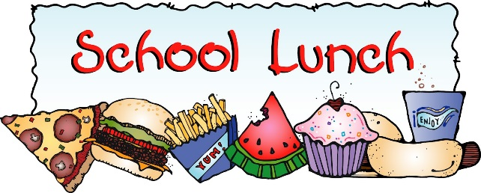
WEEK 2
2023/2024
Also available every day:
Salad, Seasonal Vegetables, Bread and Juice or Milk. Quorn also available upon request.

