Welcome to
Wharton C of E Primary School
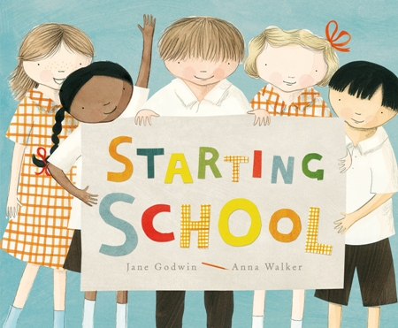

Train up a child in the way they should go and when they are old they will not depart from it.
Proverbs 22 v 6

We have made this booklet to show you some of the lovely things we do at school and to help you get to know more about your new classroom.

We hope you enjoy sharing our book with your family.

Here are the grown-ups who work in the Reception Classes.

Miss Caldwell is the teacher for Peach class.

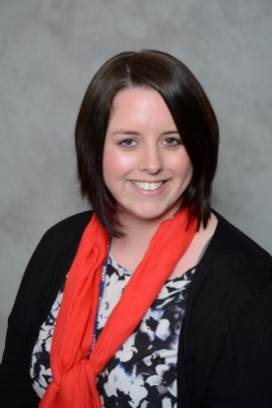

Mr Davies is the teacher for Plum class.

Mrs Rodger and Mrs Gormley are the teaching assistants.

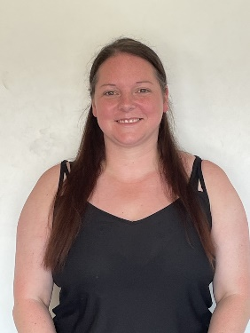
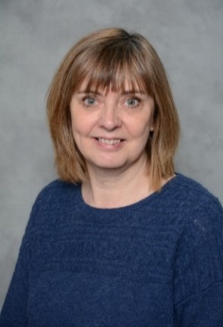

In Reception, we have a classroom and an outside area where we can play and explore, and there are many opportunities for you to have fun and learn.

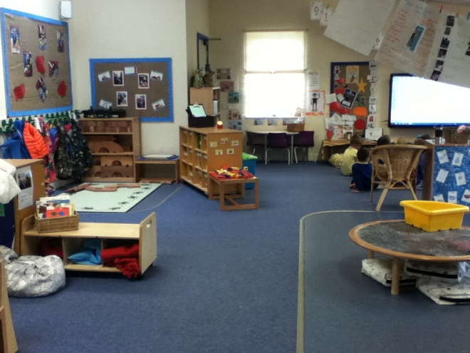

This is our colourful outside classroom; whilst we are outside we can explore and investigate our environment. We have lots of fun in the outside area. Climbing, playing in the water and painting are just some of the things you can do.

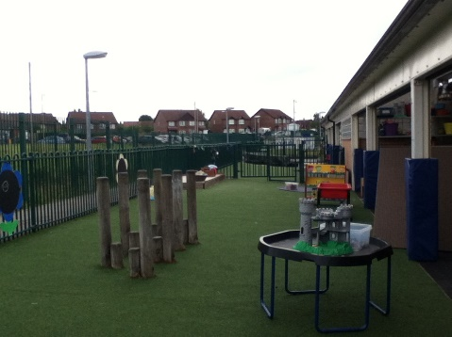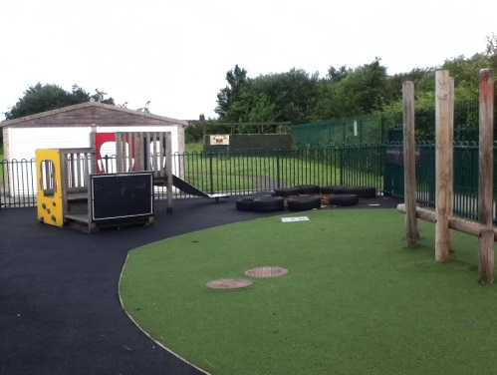
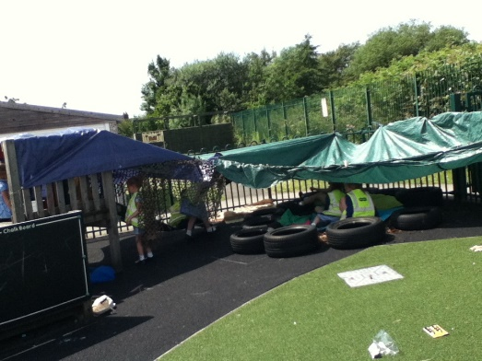

We will also be able to explore the rest of our school. This is our hall where we have assemblies, PE, and eat our lunch.

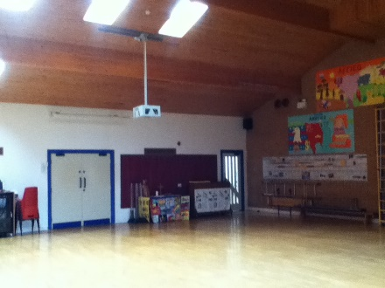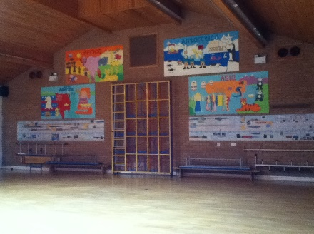

When you arrive at school in the morning, you will wait on the playground at the side of the reception classroom with your parent/carer. At 8.50am one of the reception team will open the gates and you will be able to come into your classroom.

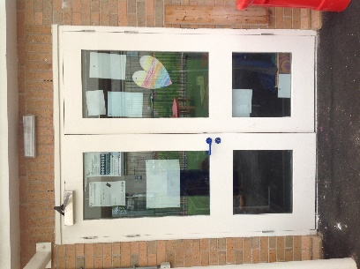

Once you have come into the classroom you will need to put your things away. In the cloakroom, you will have a peg with your name on it. You will hang your coat on your peg and put your lunch box on the trolley.

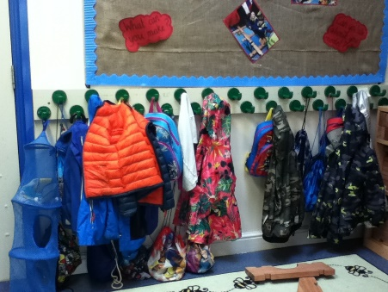
You will then put your book bag into your tray.

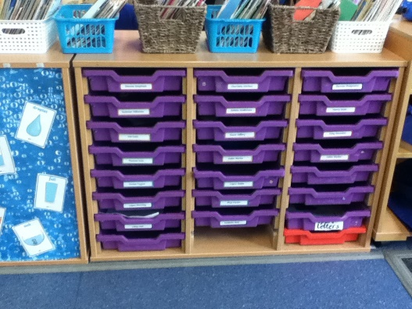

Once you have put all of your things away you will wash your hands, and then go to sit on the carpet area for register.

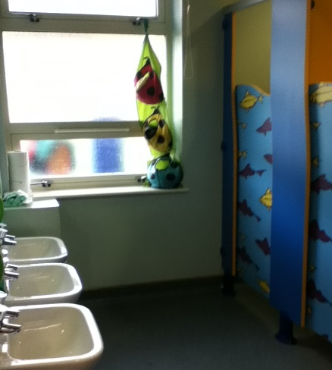

During the morning, we have snack time where you can have fruit, water or milk.

After your lunch, you will be able to play outside in the playground. When lunchtime is over one of the teachers will blow the whistle and you will line up by the gate ready to go back into class.

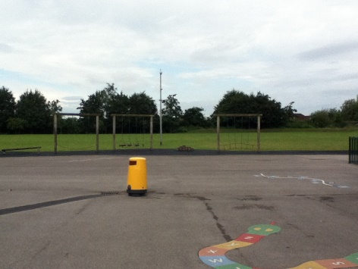

When it is home time, you will have a story read to you by your teacher and then it will be time to collect all your things ready to go home.

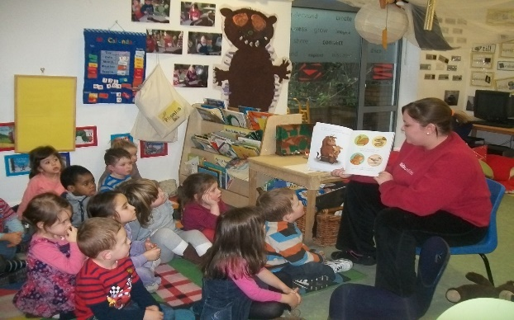

We hope you have enjoyed finding out about
your new school and what you will be doing
in Reception.
We can’t wait for you to join our
school in September.

