OPTION | MONDAY | TUESDAY | WEDNESDAY | THURSDAY | FRIDAY
A | Cheese Toastie with potato wedges | Spaghetti Bolognaise  With garlic bread | Roast Pork  with Seasonal Vegetables,  Roast & Mashed Potatoes & Gravy | Chicken Korma  with Rice & Naan Bread | Chicken Nuggets  with Chips and Seasonal Vegetables
B |  |  |  |  | Fish Fingers
 | Sandwich  with a choice of fillings (Cheese, Tuna Mayo or Ham) | Sandwich  with a choice of fillings (Cheese, Tuna Mayo or Ham) | Sandwich  with a choice of fillings (Cheese, Tuna Mayo or Ham) | Sandwich  with a choice of fillings (Cheese, Tuna Mayo or Ham) | Sandwich  with a choice of fillings (Cheese, Tuna Mayo or Ham)
C | Jacket Potato  with a choice of fillings (Cheese, Tuna Mayo or Baked Beans) | Jacket Potato  with a choice of fillings (Cheese, Tuna Mayo or Baked Beans) | Jacket Potato  with a choice of fillings (Cheese, Tuna Mayo or Baked Beans) | Jacket Potato  with a choice of fillings (Cheese, Tuna Mayo or Baked Beans) | Jacket Potato  with a choice of fillings (Cheese, Tuna Mayo or Baked Beans)
Dessert  Options | Raspberry & White Chocolate Muffin | Chocolate Sponge | Jelly | Cornflake cake | Shortbread
 | Fresh Fruit | Fresh Fruit | Fresh Fruit | Fresh Fruit | Fresh Fruit
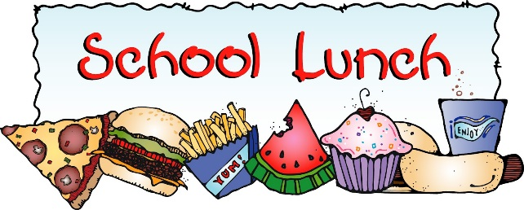
WEEK 3
2023/2024
Also available every day:
Salad, Seasonal Vegetables, Bread and Juice or Milk. Quorn available upon request.

