|  |  |  |  |  |  |
| --- | --- | --- | --- | --- | --- |
| **OPTION** | MONDAY | TUESDAY | WEDNESDAY | THURSDAY | FRIDAY |
| A | Cheese Toastie  & Wedges | Spaghetti Bolognese  With garlic bread | Toad in the hole  with Seasonal Vegetables,  Roast & Mashed Potatoes & Gravy | Curry, Rice & Naan Bread | Chicken Burger  & Chips |
| **B** | Fish Fingers |
|  | Sandwich  with a choice of fillings *(Cheese, Tuna Mayo or Ham)* | Sandwich  with a choice of fillings *(Cheese, Tuna Mayo or Ham)* | Sandwich  with a choice of fillings *(Cheese, Tuna Mayo or Ham)* | Sandwich  with a choice of fillings *(Cheese, Tuna Mayo or Ham)* | Sandwich  with a choice of fillings *(Cheese, Tuna Mayo or Ham)* |
| C | Jacket Potato  with a choice of fillings *(Cheese, Tuna Mayo or Baked Beans)* | Jacket Potato  with a choice of fillings *(Cheese, Tuna Mayo or Baked Beans)* | Jacket Potato  with a choice of fillings *(Cheese, Tuna Mayo or Baked Beans)* | Jacket Potato  with a choice of fillings *(Cheese, Tuna Mayo or Baked Beans)* | Jacket Potato  with a choice of fillings *(Cheese, Tuna Mayo or Baked Beans)* |
| Dessert  Options | Ginger Biscuit | Iced Sponge | Eaton Mess | White Choc & Raspberry Muffin | Shortbread |
| Fresh Fruit | Fresh Fruit | Fresh Fruit | Fresh Fruit | Fresh Fruit |

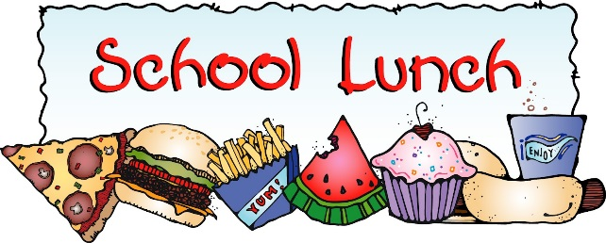 WEEK 1

**2025/2026**

