|  |  |  |  |  |  |
| --- | --- | --- | --- | --- | --- |
| **OPTION** | MONDAY | TUESDAY | WEDNESDAY | THURSDAY | FRIDAY |
| A | Cheesy Pasta  & Garlic Bread | Brunch  Pork Sausage, Hash Browns, Scrambled Eggs, Mushrooms, Fresh Tomato & Baked Beans | Gammon Roast  with Seasonal Vegetables,  Roast & Mashed Potatoes & Gravy | Chicken Fried Rice | Pizza  with Chips and Seasonal Vegetables |
| B | Fish Fingers |
|  | Sandwich  with a choice of fillings *(Cheese, Tuna Mayo or Ham)* | Sandwich  with a choice of fillings *(Cheese, Tuna Mayo or Ham)* | Sandwich  with a choice of fillings *(Cheese, Tuna Mayo or Ham)* | Sandwich  with a choice of fillings *(Cheese, Tuna Mayo or Ham)* | Sandwich  with a choice of fillings *(Cheese, Tuna Mayo or Ham)* |
| C | Jacket Potato  with a choice of fillings *(Cheese, Tuna Mayo or Baked Beans)* | Jacket Potato  with a choice of fillings *(Cheese, Tuna Mayo or Baked Beans)* | Jacket Potato  with a choice of fillings *(Cheese, Tuna Mayo or Baked Beans)* | Jacket Potato  with a choice of fillings *(Cheese, Tuna Mayo or Baked Beans)* | Jacket Potato  with a choice of fillings *(Cheese, Tuna Mayo or Baked Beans)* |
| Dessert  Options | Cornflake Cake | White choc & raspberry biscuit | Oatie | Chocolate Orange Sponge with choc sauce | Chocolate crunch |
| Fresh Fruit | Fresh Fruit | Fresh Fruit | Fresh Fruit | Fresh Fruit |

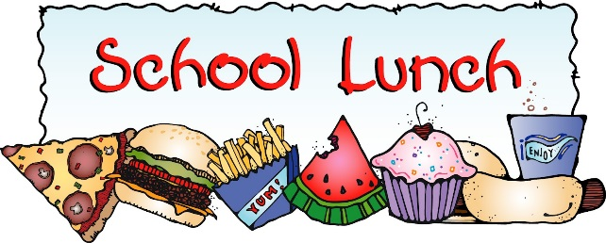 WEEK 2

**2025/2026**

